# EDUCATION

## MCA

### Chandigarh University

*07/2021 - 07/2023*,

## Bachelor Of Science

### Khalsa College For Women, Civil Lines, Ludhiana, Panjab University

*07/2016 - 07/2019*,

*Courses*

Computer Application

## Intermediate(PSEB)

### Govt. Senior. Secondary School, Sunam

*03/2015 - 03/2016*,

*Courses*

Non-Medical

## Matriculation(PSEB)

### Shree Atam Vallabh Jain School, Sunam

*03/2013 - 03/2014*,

# PERSONAL PROJECTS

#### A video sharing website using HTML, CSS, JavaScript. (06/2022 - Present)

In this project I have done video sharing website design like YouTube using HTML,CSS and JavaScript and this website design is completely inspired by YouTube.

I have created two pages, First page of this website is home page with left sidebar, one banner and list of videos with thumbnail, videos title and channel info, then second page created of this website that is video watch page. On this page video and video information, channel information, list of comments is added.

This website is also responsive for small devices. Because of this project I learnt the basics of HTML, CSS, JavaScript.

# SKILLS

HTML      CSS     

JAVASCRIPT      PYTHON     

C      C++     

# ACHIEVEMENTS

#### IELTS Exam (Overall 6 band) Dance Competition Sports(Chess)

Speech Competition Singing Competition

# CERTIFICATES

#### Crash Course on Python(Coursera) (10/2021 - 12/2021)

*In this course, I learnt the basics of Python Language.*

One day Workshop of Python by CETPA (12/2021 - 12/2021)

# LANGUAGES

English

*Full Professional Proﬁciency*

Hindi

*Full Professional Proﬁciency*

Punjabi

*Native or Bilingual Proﬁciency*

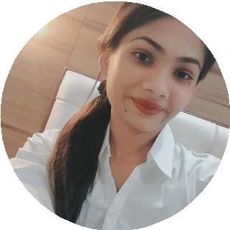

[linkedin.com/in/shaﬀy-garg-73988b237](https://www.linkedin.com/in/shaffy-garg-73988b237)

Sunam, Dist.Sangrur, India

8288080654

[shaﬀygarg186@gmail.com](mailto:shaffygarg186@gmail.com)

Shaﬀy Garg

Student

Self-motivated, highly passionate and hardworking fresher looking for an opportunity to work in a challenging organization to utilize my skills and knowledge to work for the growth of the organization.

# INTERESTS

Art

Cooking

Reading

Chess

#### 

Photography

Travelling

Dance

Listening to Music